FOR IMMEDIATE RELEASE:
Duck Hill Resident Wins Statewide Home Care Recognition
The Mississippi Association for Home Care (MAHC) is proud to announce that Christie Winters, RN of Duck Hill, Mississippi has received statewide recognition as the recipient of the 2018 J.T. Gilbert Clinical Award.
Winters has been a Home Health Nurse for Sta-Home for 4 years, recently becoming a Clinical Supervisor for the Clarksdale area. As noted in her nomination, Winters does not allow obstacles to stand in the way of her providing exemplary care to her patients while her cheery disposition and smiling face are continuous motivation for her co-workers.
The J.T. Gilbert Clinical Award was established in 1991 to honor all professional clinical disciplines that work in the home health field. The criteria are specific that the individuals nominated must be involved in direct patient care and must demonstrate excellence in the home care field.
The Mississippi Association for Home Care is a non-profit membership organization dedicated to operating for the benefit of member home health agencies, home heath related agencies and the benefit of the public in fostering and maintaining high standards of home health care.
For more information, contact Mary Lea Nations, Executive Director of MAHC at 601-924-2275, or mnations@mahc.org.

Images Below-

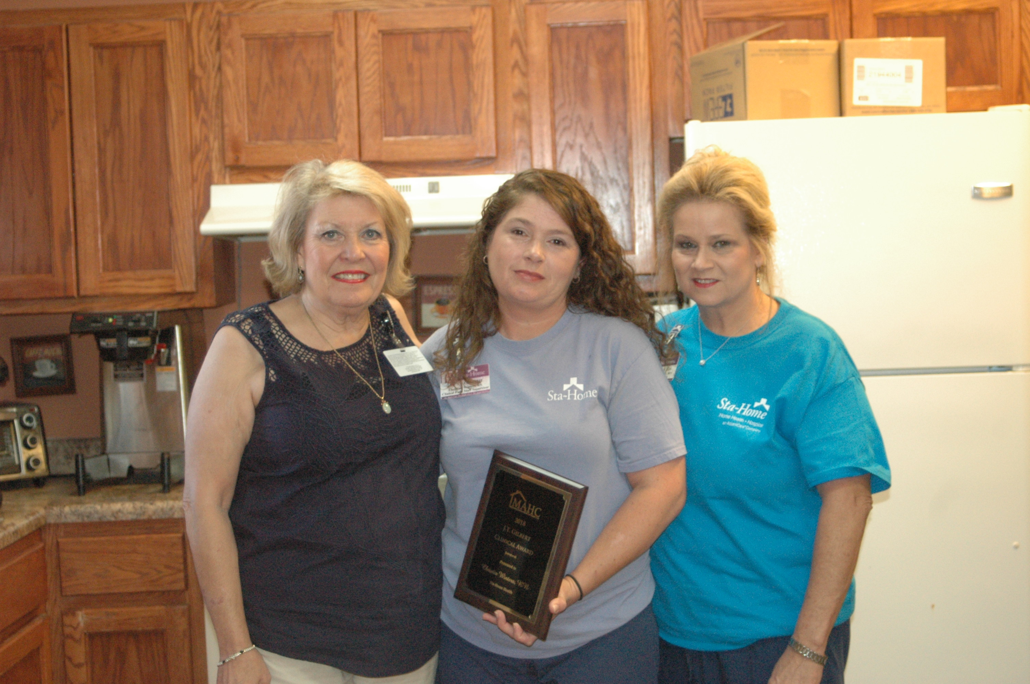

Joan Hamilton, Christina Winters, and Natalie DeLoach of Sta-Home Batesville.

